

**Model: WT111RJ**

# APPLICATIONS:

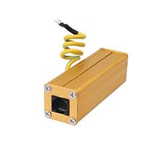

Designed for Audio device not to be spoiled by lightning over-voltage, induced over-voltage and static discharge.

* Telephone, Fax,
* ISDN, DDN, DSL
* Broadcast system

# FEATURES:

* Multi. Protection circuits, Gas-Tube+ TVS technology
* Dual protection in Common module and different module
* Multi-Strike Capability

# TECHNICAL PARAMETER：

**WT111RJ**

**Model**

**Electrical Parameter**

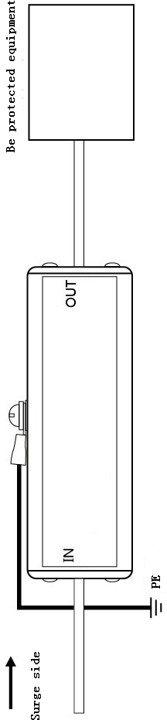Max. continuous operating voltage **Uc** 110V DC spark-over voltage 150V±20%

Nominal discharge current（8/20µs）**In** 10kA

Max. discharge current （8/20µs）**Imax** 15kA

Limiting voltage (10/700µs) **Up** 500V

Adapt transmission rate **Vs** 100Mbps

Insertion loss **Ae** 0.5dB

Protection line 3/4

Response time **Ta** 100ns

Interface form RJ11

Protection line 2

Protection port 1

54(L) ×25(W) ×25(H)mm

Dimension

**Mechanical characteristics**

Weight per unit 50g

IP Code IP20

Working conditions Temperature: -40 to 85℃, Relative humidity: ≤95％

Standards compliance IEC61643-1, RoHS

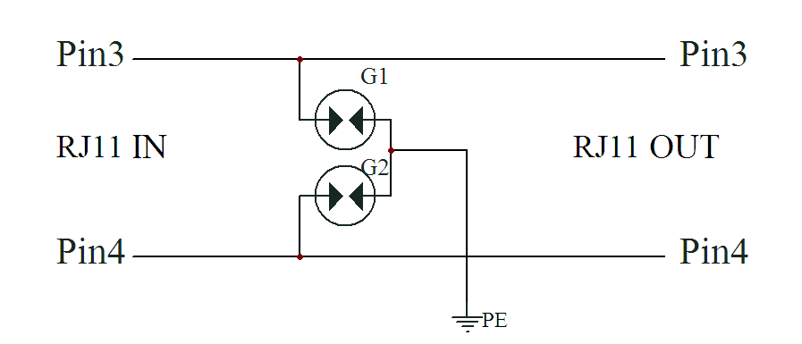

**Welltech Enterprises**

415 Ground Floor, PRAKASH MOHALLA, GARHI , EAST OF KAILASH

NEW DELHI 110065

Phone +91 9871650366 Email : sales@welltechenterprises.in